1)what is software? What is software engineering?

Ans: software is a set of instruction,data or programs used to operate computers and execute specific task.

Software engineering: software engineering is the branch of computer science that deals with the design,development,testing and maintenance of software applications.

2)explain types of software?

Ans: 1)appilcation software

2)system software

3)driver software

4)middleware software

5)programming software

3) what is SDLC? Explain each phase of SDLC

Ans: software develop life cycle is a structured process that is used to design, develop, and test good-quality software.

1. Planning: planning is a crucial step in everything, just as in software development.
2. Analysis: this phase involves gathering information about the software requirements from stakeholders, such as customers, and users, and business analysts.
3. Design: in this phase, the software design is created, which includes the overall architecture of the software,data structures, and interfaces.
4. Implementation: the design is then implemented in code, usually in several iterations and this phase is also called as development.
5. Testing: the software is thoroughly tested to ensure that it meets the requirements and works correctly.
6. Maintenance: this phase includes ongoing support, bug fixes, and updates to the software

4)what is DFD? Create a diagram on flipkart .

Ans: a data flow diagram is a graphical or visual representation that uses a standardized set of symbol and notations to describe a business operation through data movement.

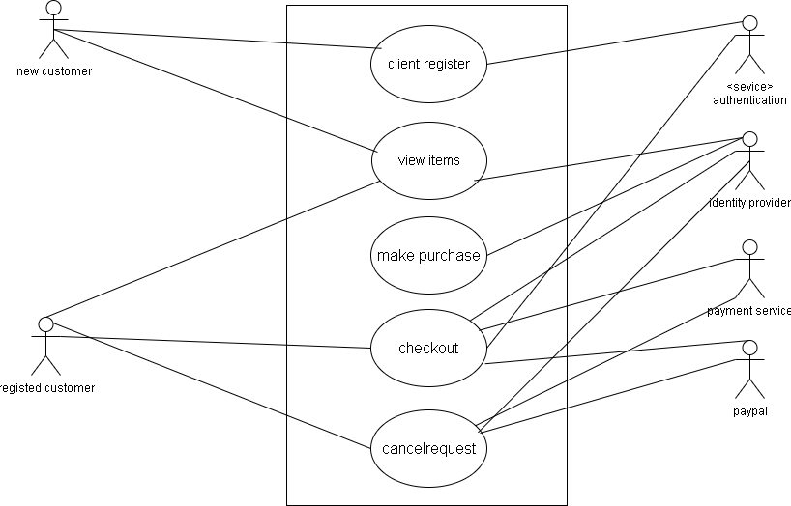

5) what is flowchart? Create a flowchart to make addition of two numbers.

Ans: flowchart are nothing but the graphical representation of the data or the algorithm for a better understanding of the code visually.

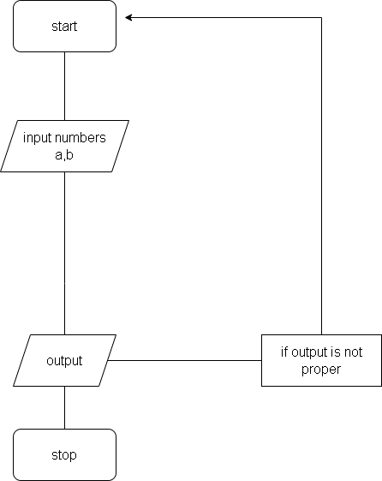

1. What is use case diagram? Create a use-case on bill payment on paytm.

Ans: a use case diagram is a graphical depiction of a users possible interactions with a system.

